**CSE 564 - Visualization**

**Lab 1 Report**

Submitted By -

*Tarun Lohani*

*110921666*

URL -

Data set chosen - baseball_data.csv

Tasks -

1. Pick a variable and bin it into a fixed range (equi-width) of your choice.

2. Create a bar chart of the variable you picked in 1.

3. Using a menu, allow users to select a new variable and update chart.

4. Only on mouse-over display the value of the bar on top of the bar

5. On mouse-over make the bar wider and higher to focus on it

6. On mouse-click transform the bar chart into a pie chart (and back)

7. Mouse moves left (right) should decrease (increase) bin width/size

Extra credit : On mouse-click create a force-directed layout using a chosen distance

In this project I have taken baseball players data and tried to visualize this data as bar chart, pie chart and a force chart. The user can switch among height, weight and heart rate of the players using the menu buttons in the right. All the charts show the number of players for a particular range of heights, weights and heart rates. All the tasks and their implementations are described in the following sections.

**Task 1 - Pick a variable and bin it into a fixed range (equi-width) of your choice.**

**Task 2 - Create a bar chart of the variable you picked in 1.**

Heights, weights and heart rates of the baseball players have been binned to different ranges for each variable to start with. I have used d3.layout.histogram() API to bin and show the data as a histogram.

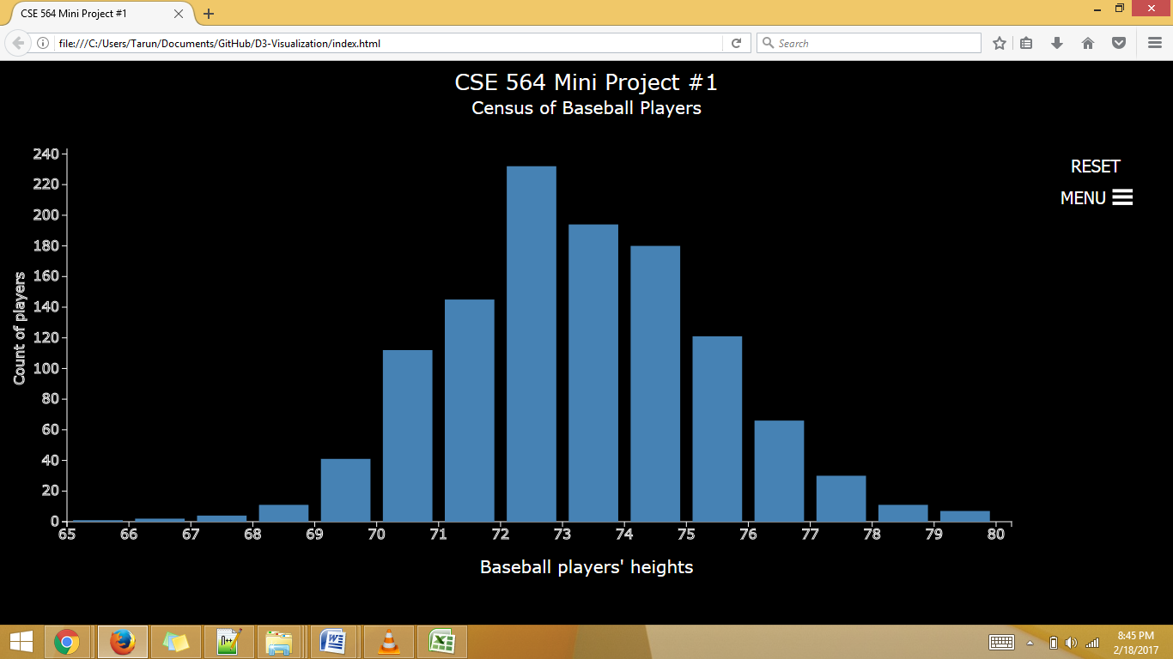

**Task 3 - Using a menu, allow users to select a new variable and update chart.**

User can use the menu items in the right side of the webpage to switch among the three variables - Height, Weight and Heart rate. In the code, I am refreshing the chart every time based on type of variable selected by the user.

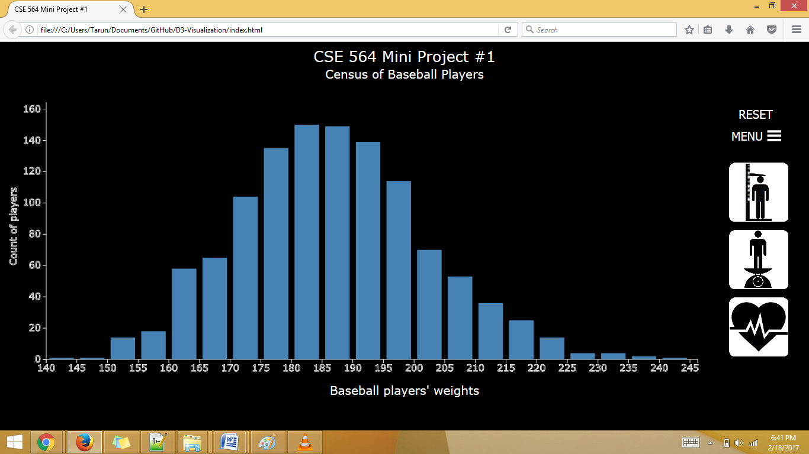

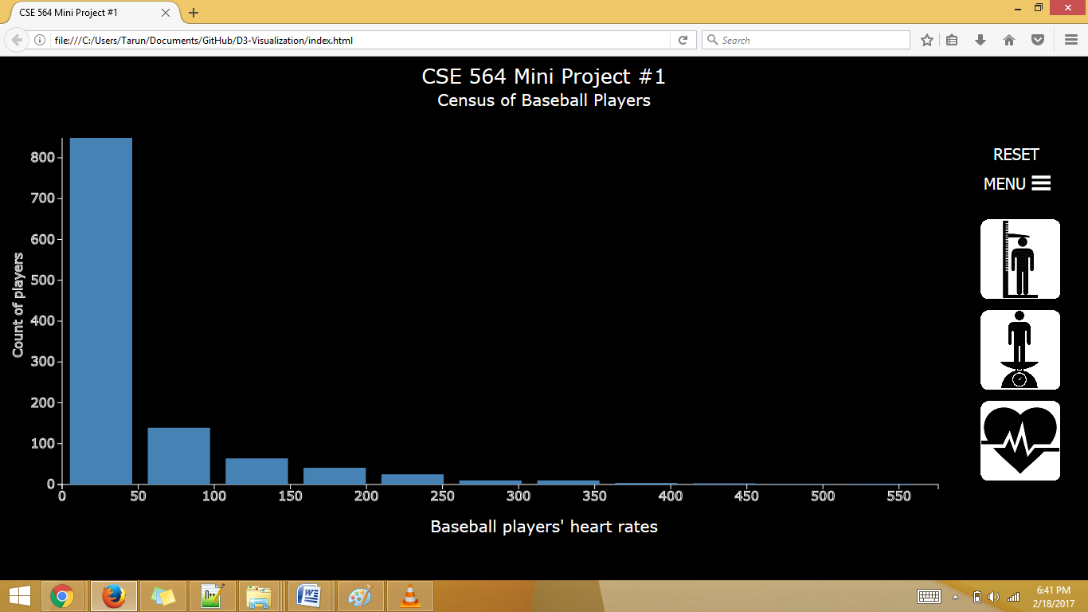

**Task 4 - Only on mouse-over display the value of the bar on top of the bar.**

**Task 5 - On mouse-over make the bar wider and higher to focus on it.**

On the mouse hover on any bar, it shows the value of the bar on the top of the bar. The respective bar changes its size and becomes wider. Also the bar changes its color from steel blue to red. The logic for these tasks is written on the mouseover and mouseout events of the 'rect'. On mouseover I am increasing the width, changing the position and changing the color of the bar saving the actual dimensions. On the mouseout event, I am reverting everything to its original value.

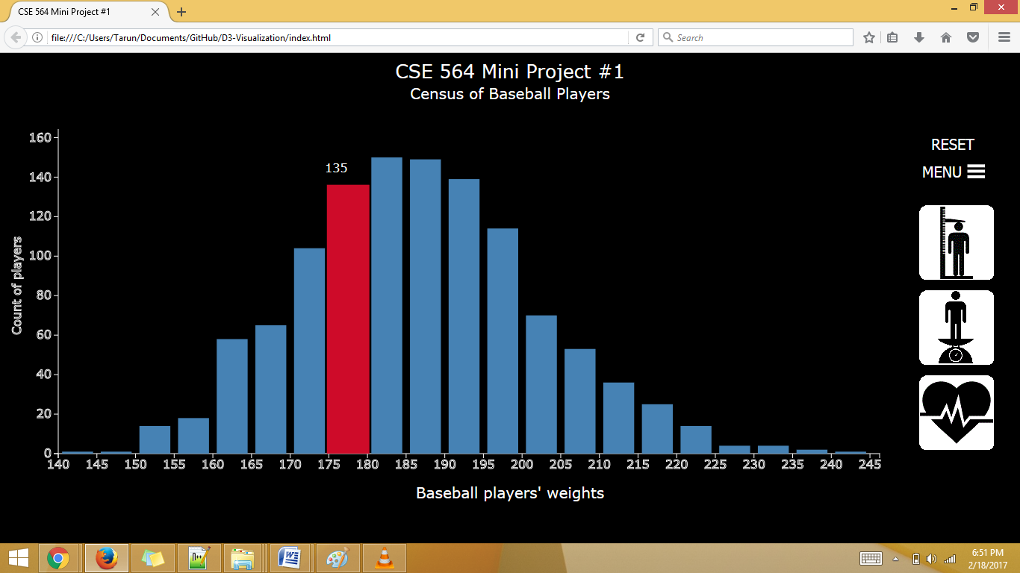

**Task 6 - On mouse-click transform the bar chart into a pie chart (and back).**

Clicking on the histogram, it is converted to pie chart with the same number of slices as the number of bins in the histogram. Legend area is also created based on the slices. I am using d3.layout.pie() API to show the pie chart.

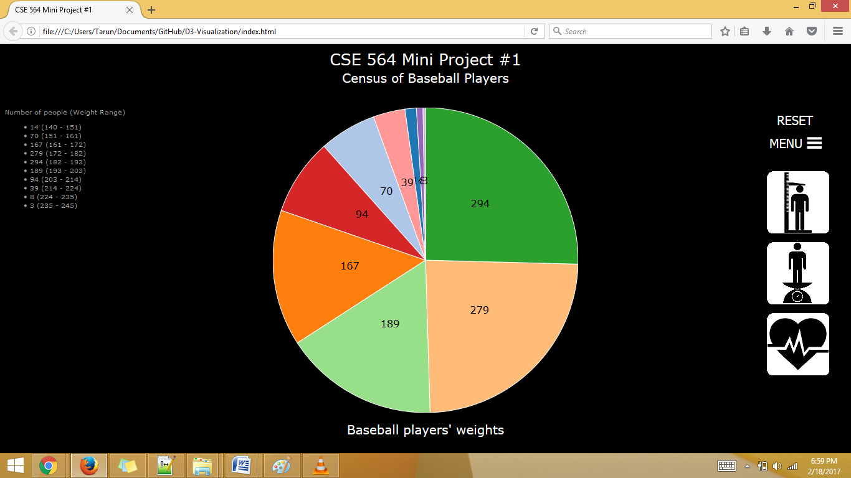

**Task 7. Mouse moves left (right) should decrease (increase) bin width/size**

Once the user clicks on the histogram and drags the mouse right or left the number of bins increase or decrease by one. The lower limit of the number of bars is set to 1. Also the vertical and horizontal axes are updated accordingly. While dragging the mouse, hover events (increasing the bar size and focus the bar) is disabled. All these tasks are implemented by writing the logic in mousedown, mouseover and mouseup events of the chart layout. The bars and axes are being recreated after the user has dragged the mouse for a certain length (100 px) horizontally. The hover properties are then retained.

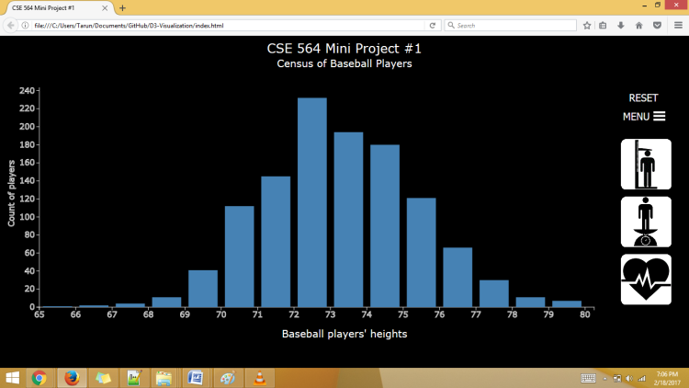 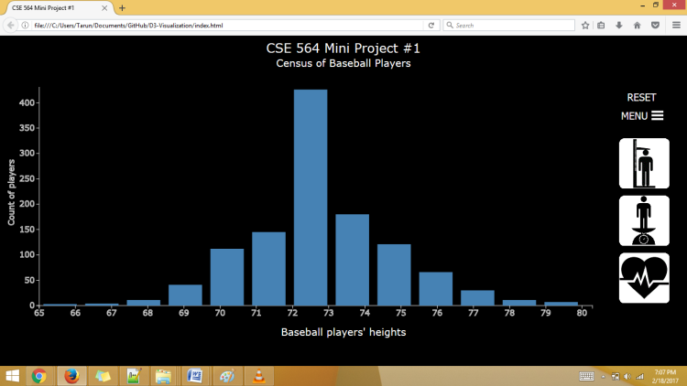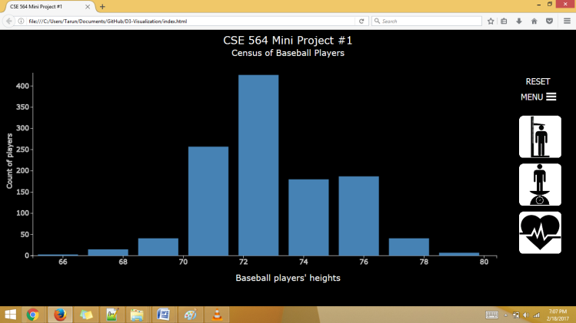 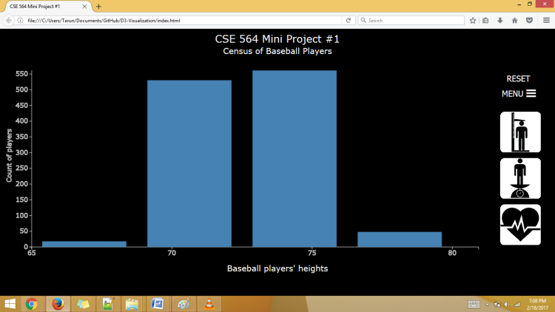

**Extra credit : On mouse-click create a force-directed layout using a chosen distance**

Clicking on pie chart it is converted to a force-directed layout with a constant distance with different number of nodes showing their respective value and connected to the parent node which shows the type of variable chosen (height, weight or heart rate). The number of nodes are same as the number of bins in the histogram or number of slices in the pie chart. To go back to the histogram, user will have press the reset button placed above the menu button. I have used d3.layout.force API to implement the force chart. The force layout is flexible and the nodes can be dragged to change their positions.

